Assignment 6 - Outside the processor

1: Using the cat command list the information found in the /proc directory about the computer CPU’s.

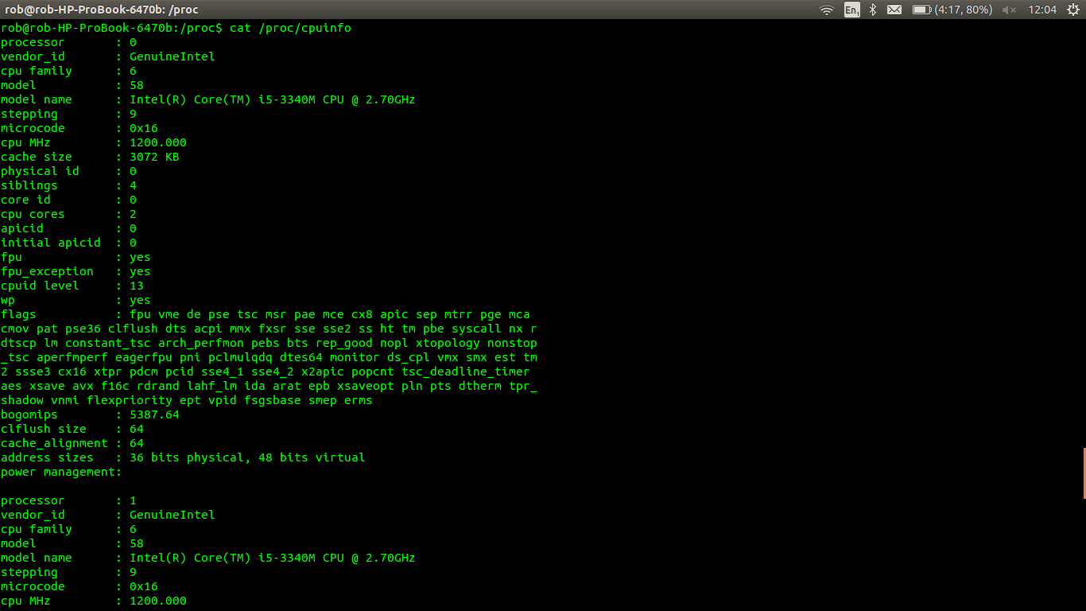

2: Provide a table showing all the interrupts available on the system and how many of each there has been since boot time. How many interrupts are available for each processor.

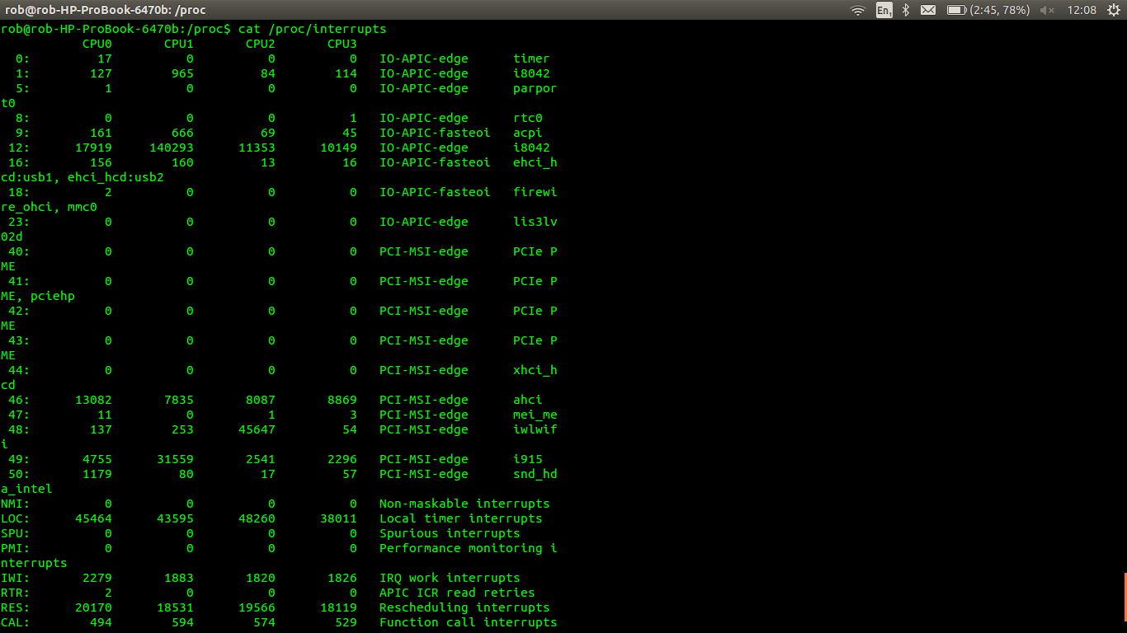

3: Show number of CPUs, the producer of the CPUs and the CPU Model.

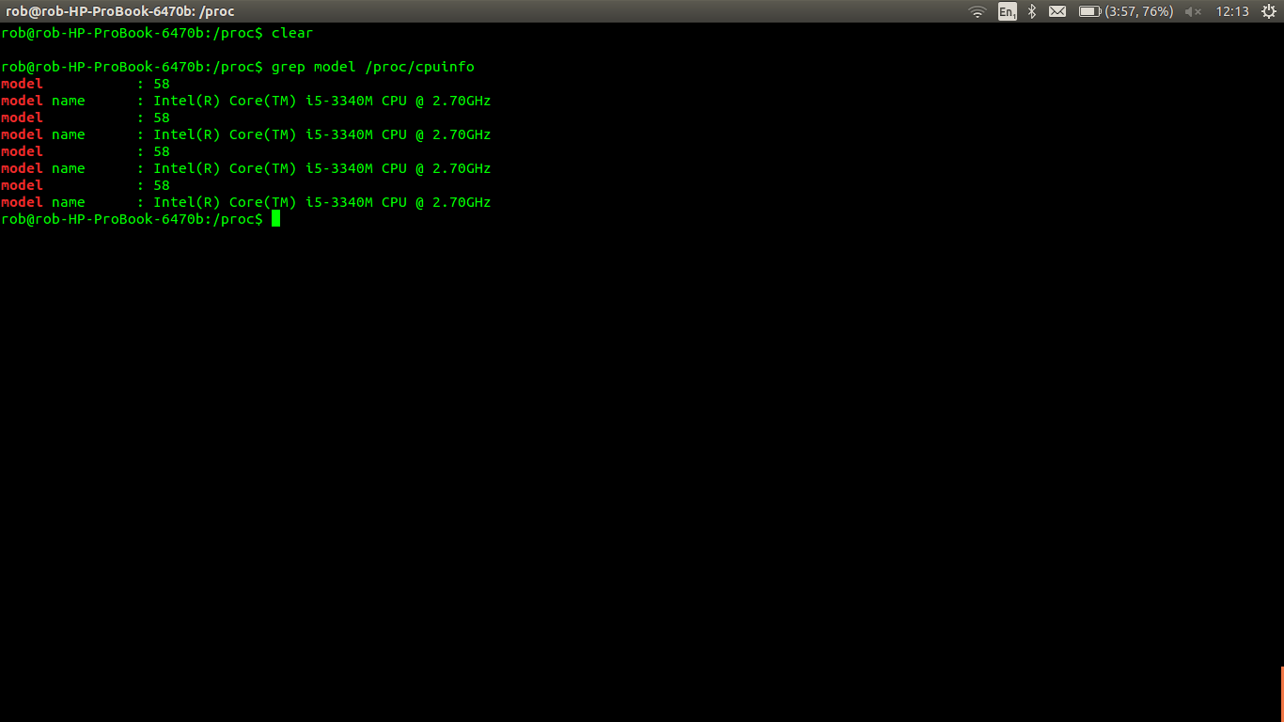

4 Show the parameters that are passed to the kernel when starting up linux.

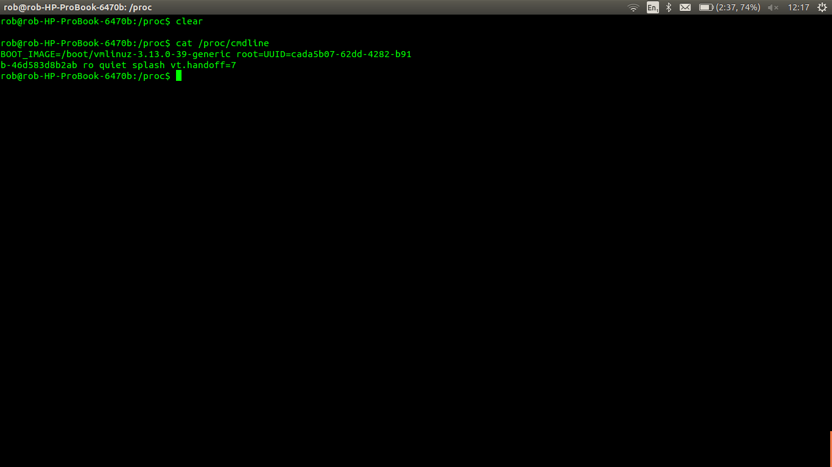

5: Using /proc/diskstats show the name of the output devices and the number of megabytes read per second during the second sampled interval.

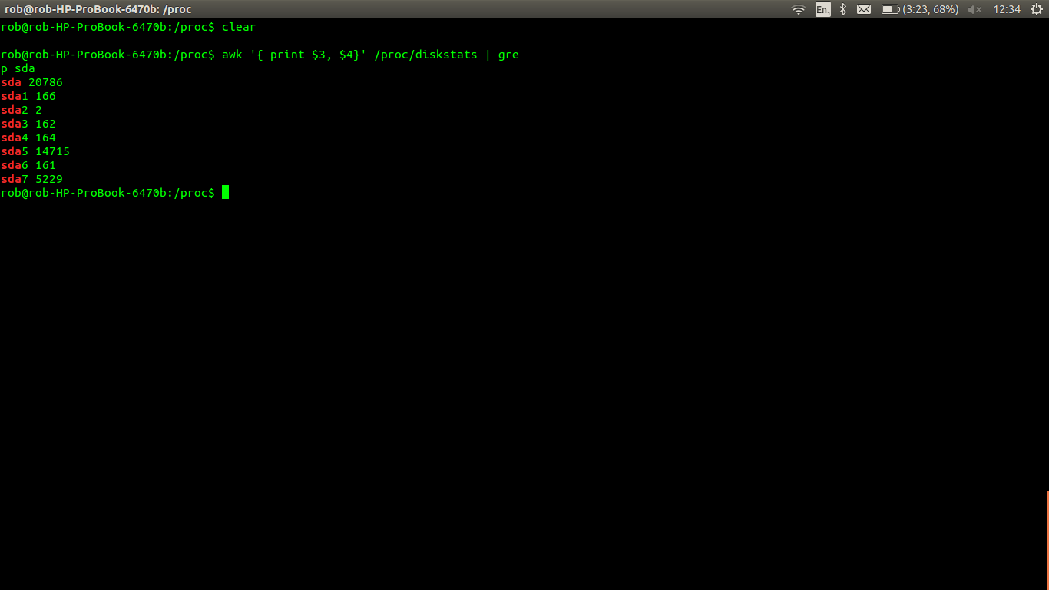

6: Using while and case statements develop a menu based shell script to allow the user to select from the following:

#!/bin/bash

# DISPLAYS A MENU

while true;

do

echo "1. Display information about the CPU. "

echo "2. Display the interrupts system. "

echo "3. Display a process PID for a process on the system and its status. "

echo "4. exit. "

read input_variable

#STORES THE INPUT INTO A VARAIBLE CALLED "input_variable"

echo "Your choice was $input_variable"

#CASE STATEMENT TO DIFFERENTIATE OUTPUT RESPECTIVE TO THE USER'S CHOICE.

case "$input_variable" in

1) #Display CPU info

echo Displaying CPU information

grep model /proc/cpuinf

;;

2) #Display the interrupts info

echo Displaying interrupts

cat /proc/interrupts

;;

3) #Display the PID and its status.

echo Enter PID

read input2

ps -p "$input2"

;;

4) #stop the script

break

;;

#END CASE STATEMENT

esac

#END OF WHILE LOOP

done

echo "Exiting"